|  |  |
| --- | --- |
|  | ***Summer Quarter 2014 Course Announcement***  **Center For Multicultural Education**  **EDC&I 505A (Seattle) B EDUC 520 A(Bothell)**  **Race, Class, Gender, and Social Inequality**  **M-F 1:10-4:30PM, July 21st – August 1st**  **Dempsey Hall 002**  **schedule line #11184 (Seattle), # 10315 (Bothell), 3 credits, CR/NC**  **e-mail:** [**edcodes@uw.edu**](mailto:edcodes@uw.edu) **for add code/registration questions** |

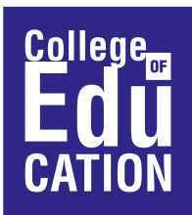

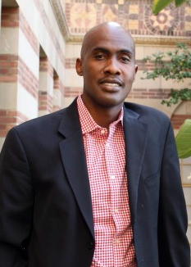

Instructor: ***Tyrone Howard***

***Faculty Director, Center X and Director, Black Male Institute***

***Graduate School of Education and Information Studies***

***University of California at Los Angeles***

**Course Description**

Education has been viewed as one of the most viable and effective routes to upward mobility in the United States.  An educated citizenry has also been seen as a key element in the maintenance of democracy.  However, access to public education has not always been available to all segments of our society. This course will provide students with a basis for understanding the educational experiences of different groups in the United States.  We will focus extensively on the following groups: African Americans, Asian Americans and Pacific Islanders, Chicanas/os/Latinas/os, Native Americans, women, and low-income White Americans.  The experience of these groups in U.S. public schools and their efforts to utilize education to improve their socio-economic status will serve as the focus for the course.

|  |  |
| --- | --- |
| Center for Multicultural Education University of Washington 110 Miller Hall, Box 353600 Seattle, WA 98195-3600 Phone: (206) 543-3386 Fax: (206) 543-1237 Email: [centerme@u.washington.edu](mailto:centerme@u.washington.edu) Website: <http://education.uw.edu/cme> |  |