Handbook for Revising or Proposing New Programs or Certificates in the College of Education

Adopted by Faculty Council
January 31, 2014

Revised: 7/11/2023

Table of Contents
Overview 3
Procedures for Proposing a New Program or Certificate 3
Procedures for Revising a Program or Certificate 3
College of Education Procedures Flow Chart 4
Steps for Programs and Certificate Proposal Review and Internal COE Approval 6
Definitions and Documentation Required 9
Graduate Programs 9
Undergraduate Programs 11
Appendices 13
Appendix A: New Graduate Degree (Program) Proposal Form 14
Appendix B: New Graduate Degree (Program) Option Proposal Form 19
Appendix C: New Graduate Certificate Proposal Form 22
Appendix D: Revising Graduate and Undergraduate Programs and Certificates 25
Appendix E: New Undergraduate Degree (Major) Proposal Form 27
Appendix F: New Undergraduate Degree (Program) Option Proposal Form 30
Appendix G: New Undergraduate Minor Proposal Form 32

Overview

This handbook provides guidance to faculty groups that intend to propose expansions or alterations to academic programs of the College of Education (COE). It includes a list of the required COE procedures and the documentation required by the COE, the Graduate School, and the UW Faculty Council on Academic Standards (FCAS).

Procedures for Proposing a New Program or Certificate

To propose a new program, degree, degree option, certificate, or undergraduate minor, the first step is to share the idea with the appropriate leadership in the unit (see below step 1). The next step is to bring together all impacted faculty and determine the nature and scope of the new program. If the faculty at the meeting decide to move forward, a member of the group making the proposal shall lead the group in preparing the elements listed in the appropriate “required documentation” forms, which can all be found in the appendices of this handbook.

Next, the required documentation should be submitted as a proposal to the Innovation Support Team (IST), the sounding board for reviewing, evaluating, and recommending strategies, plans, and policies for innovative programs associated with the College of Education. New programs/certificates often have budgetary implications; therefore, consulting the IST will allow for the financial implications to be integrated into the planning for the new program. The remaining internal COE procedures are described in detail after the flowchart on the next two pages.

Procedures for Revising a Program or Certificate

Faculty groups seeking to revise a program/certificate should share the idea with the appropriate leadership in the unit and should consult with the Academic Programs and Initiatives Committee (APIC) and the Associate Dean for Academic Affairs before initiating the revision process. Depending on the type of revision, procedural steps may vary from a condensed process to the same number of steps as proposing a new program. Consulting first will allow for faculty to receive support in determining whether revisions to a program are minor or significant changes. (See pages 10 - 12 for some examples of minor and substantive changes.) The remaining internal COE procedures are described in detail after the flowchart.

The flowchart on the following pages identifies the internal COE procedures to follow for both new and revised programs.

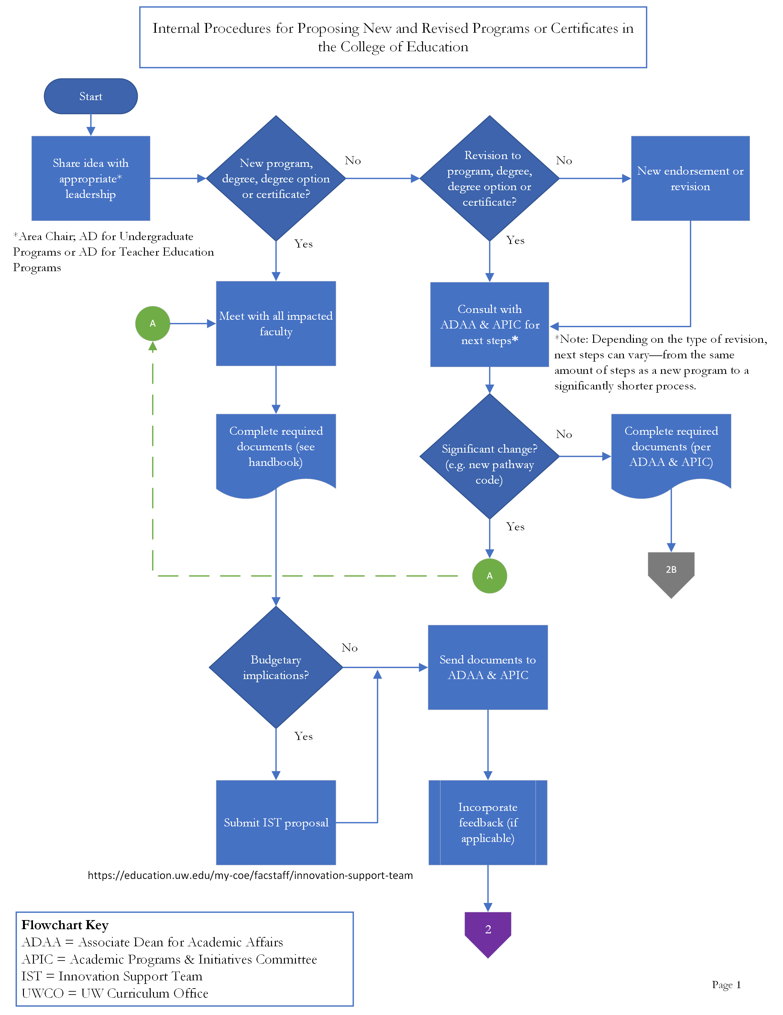
College of Education Procedures Flow Chart
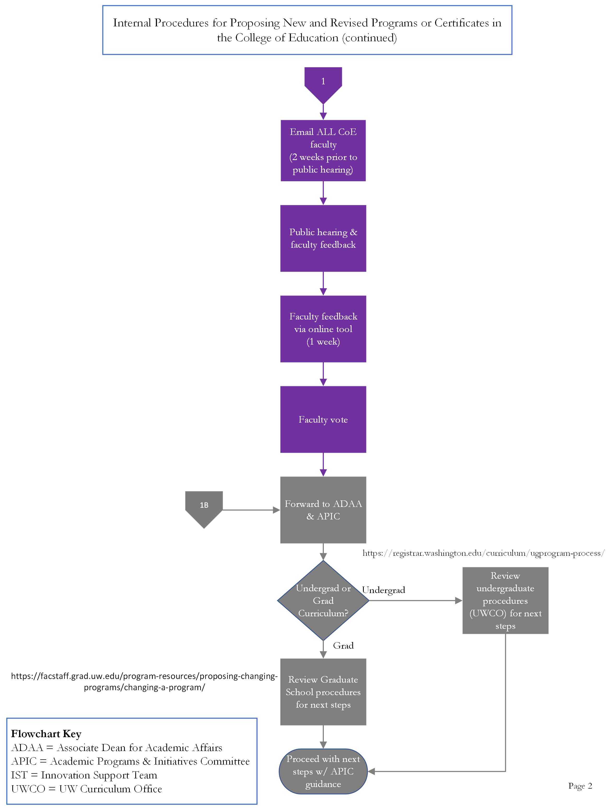

Steps for Programs and Certificate Proposal Review and Internal COE Approval

- Convening of impacted faculty and consulting with Associate Dean for Academic Affairs (ADAA) and Associate Director of Academic Planning and Curriculum Management. As mentioned previously, the first step to proposing a new program or certificate is to share your idea with the appropriate leadership in the unit. For all proposals, reach out to the Area Chair. In addition to the Area Chair, for teacher education proposals, reach out to the Assistant Dean for Teacher Education Programs. For undergraduate proposals, reach out to the Assistant Dean for Undergraduate Programs in addition to the Area Chair. Next, convene the group of faculty that would be contributing to (or impacted by) the new program/certificate. This group should identify a faculty lead who will facilitate the application process and work with the Associate Dean and APIC to prepare the materials for FCAS (for undergrad programs) or the Graduate School (for graduate programs).

The first step to revising a program or certificate is to share your idea with the appropriate leadership in the unit (see above). Next, consult with the ADAA and the Associate Director of Academic Planning and Curriculum Management. The faculty lead who is proposing the program change should request a brief meeting to obtain an initial opinion on whether the change will be minor or a significant change.

If the change is perceived to be minor, the proposer will be advised to complete the proposal form found in the appendices of this handbook. The ADAA and APIC will review the required documents, provide feedback, and determine the procedures to follow to complete the minor program changes. Minor changes may result in submitting changes to the time schedule, OnCourse, updating PCE registration forms, updating a course of study, updating the COE website or other minor changes that involve working with other units and personnel.

If the consultation determines that a significant change is desired, the faculty lead will be advised to proceed with convening all impacted faculty to discuss the changes and prepare the required documentation. If there are no budgetary implications, completed materials can be sent to ADAA and APIC for review, otherwise they will go to the IST before proceeding with the ADAA and APIC.

- Innovation Support Team (if necessary). There are usually budgetary implications for new programs, degree options, and certificates, so the required documentation should be forwarded to the IST. This team will be able to offer support to the faculty group on addressing the financial considerations for the new program. These considerations will be added to the proposal before proceeding to the next step. As part of the IST review, the Dean will be informed about budgetary implications of approving the new program.

- Forwarding proposal documents to the Associate Dean for Academic Affairs (ADAA) and the Academic Programs and Initiatives Committee (APIC) of the Faculty Council. The program/certificate lead shall send the appropriate proposal form and required documentation materials to the ADAA and APIC for review. This shall include a draft of the Memorandum of Agreement if the program will be a fee-based program. The ADAA will discuss the proposal at the Dean Team meeting at this point in the process. The ADAA and the APIC will provide feedback on the proposal and return, in writing, that feedback to the appropriate faculty group within two weeks. Appropriate changes should be made to the materials at that time.

- Alerting the full faculty regarding a COE public hearing. After all faculty who contribute to the core of the program/certificate determine the nature and scope of the program/certificate, all faculty especially any who could conceivably be impacted by the program/certificate should be invited to assemble to discuss the proposal. At a minimum, invitations should extend to faculty teaching courses impacted by the program/certificate (to discuss which of the courses will be required, optional, or deleted from requirements), undergraduate program advising staff (if appropriate), and faculty in existing programs/certificates potentially impacted by the new program/certificate. To ensure broad participation, the program/certificate lead shall send an email to the faculty alerting them to a public hearing at least two weeks prior to the public hearing and the email must include attachments with the revised required documentation materials.

- Public hearing and faculty feedback. At the public hearing, the program/certificate lead shall offer a brief presentation of the proposal and have the required documentation materials available at the meeting. All faculty are encouraged to provide feedback and ask questions about the program/certificate. After the public hearing, an online version of the form will be uploaded to collect all feedback including suggestions for modifications, comments in support, comments against, and other questions that remain. There will be a one-week window for faculty to provide feedback on the online version. Results will be reviewed by the program/certificate lead.

- Faculty vote. Prior to the faculty vote, the program/certificate lead will incorporate the feedback received at the public hearing and from the online version. The lead will revise the required documentation materials accordingly, noting the changes in the text (i.e. using tracked changes, italicized text, etc.) so that faculty may easily recognize the revisions. A separate memo is also required to address the feedback that was not incorporated with a rationale for why it was not included in the revision.

An email (which will include the revised required documentation materials and the memo) will be sent to the Director of Human Resources. The Director of Human Resources will send an email to the faculty along with a link to an electronic ballot for a vote on the program/certificate proposal. Voting may occur within a two-week window. The new program/certificate will be able to continue through the development/revision process if approved by a two-thirds majority of those casting ballots, provided that at least 45% of the eligible faculty members cast ballots (as required by the COE Faculty Code). If not approved, the program/certificate lead will need to accept suggestions and repeat the vote until it passes with a two-thirds majority vote. The faculty vote on new/revised programs/certificates is binding and is not advisory to the Dean.

- Forwarding to the Dean and proceeding with external steps as required by the UW Curriculum Office (for undergraduate programs) and the UW Graduate School (for graduate programs). The faculty lead should consult with the Associate Director of Academic Planning and Curriculum Management to receive guidance on next steps.

Timelines

The speed that this process occurs will vary. Faculty advocating for new programs/certificates should expect to spend a minimum of two months in the COE’s internal process. This will allow time for the IST review, APIC to review at their monthly meetings, the public hearing, the faculty vote, the revisions, and time for the internal approvals before submitting to either the UW Curriculum Office or the Graduate School.

The Graduate School also takes a minimum of two months for its review, particularly for new programs/certificates. Undergraduate program reviews can take up to a year since there are multiple faculty bodies that review and approve the proposal along with multiple tri-campus reviews, which serves as a public hearing across the campuses. For details on the length of time for the FCAS review go to: https://registrar.washington.edu/curriculum/ugprogram-faqs/.

Definitions and Documentation Required

Graduate Programs

New Programs and Certificates
All new graduate level programs, certificates, and degree options must be approved by the UW Graduate School. The following definitions distinguish between new programs, certificates, and degree options.

A new degree program at the doctoral level involves a new intellectual focus that builds on the expertise of existing faculty and organizes that expertise in a new way. Courses and research opportunities in this proposed program are robust and worthy of several years of dedicated study. The program curriculum has a new focus and must have less than 50% overlap with other programs in the College. The new program will require a new pathway code for admissions purposes and for internal tracking purposes. Although students will receive a doctorate in the COE, it will not be specifically named as the new program, since the COE does not offer program-specific doctoral degrees. A proposal form with the required documentation details can be found in Appendix A.

A new degree program at the master’s level involves a new intellectual focus that builds on the expertise of existing faculty and organizes that expertise in a new way. This new program must have less than 50% coursework overlap with other programs in the College. The curriculum has a unique focus and students pursue careers accordingly. Since the new program will be listed on their transcripts, a new pathway code is necessary for admissions purposes and for internal tracking purposes. A proposal form with the required documentation details can be found in Appendix A.

A new degree option at the graduate level includes a course of study within an existing degree that warrants notation on the transcript in addition to the degree title but does not warrant distinct notation on the diploma. The curriculum among degree options under the same degree generally has at least 50% overlap in content and outcomes. A new graduate degree pathway code is established at the same level, type, and program as other degree options under the existing degree. A proposal form with the required documentation details can be found in Appendix B.

Example: The Teaching, Learning, and Curriculum (TLC) area offers a M.Ed. (the degree) in Curriculum and Instruction (the graduate program) and specializations in Language, Literacy, and Culture and Culturally Sustaining Education (degree options). The Graduate School offers a summary table of the graduate level program options at: https://grad.uw.edu/wp-content/uploads/OAAP_grad_program_options_compare.pdf.

A new graduate certificate program involves a series of graduate courses that constitute a coherent body of study that enhance the education of matriculated students beyond the traditional MEd, PhD, or EdD degree and the series of courses culminates in a capstone or equivalent unifying experience. The certificate requires a new pathway code for its admissions purposes. The name of the certificate will also appear on the student’s transcript. A proposal form with the required documentation details can be found in Appendix C.

Revised Graduate Programs and Endorsements
Revisions to programs and endorsements are defined as either minor changes or substantive changes as defined by the Graduate School. Minor program changes may be processed within the COE without petition to the Graduate School. However, substantive changes must follow the process and procedures defined by the UW Graduate School. For additional guidance from the Graduate School on its threshold for reviewing revised programs, visit: https://facstaff.grad.uw.edu/program-resources/proposing-changing-programs/changing-a-program/. A proposal form with the required documentation details can be found in Appendix D.

Minor program changes
Some minor changes to master’s and doctoral programs can be reviewed internally within the COE and approved by the Academic Programs and Initiatives Committee (APIC) and the Associate Dean for Academic Affairs. Other changes will require a full review by the COE faculty (in addition to the APIC review and Associate Dean approval). Example: updating a course in a course of study that does not impact degree requirements on file with the Graduate School. This type of change would only require the review of COE faculty within the program and Area and voted on by the faculty in the Area as they are directly impacted by the change.

Substantive program changes
Substantive changes to master’s and doctoral programs must be reviewed and approved by the Graduate School. Example: reducing or increasing the required credits within a program’s degree requirements. Substantive changes must be reviewed and approved within the COE first, before seeking approval of the Graduate School.

A course of study is an unofficial COE document used to provide a “roadmap” of courses for students in their chosen graduate program. Please note that the course of study may have more specific details than what appears on a degree audit with the UW Graduate School, therefore, when proposing changes to a program, it is important to note the differences between both the course of study and the degree requirements on file with the Graduate School.

The degree audit is the official program requirements document on file with the UW Graduate School. It reflects any courses and associated credits that are required for degree conferral. Because this information is so specific and at times our course offerings fluctuate, faculty are encouraged to carefully consider the courses and list any alternative options to these requirements. Example: 2 courses – EDPSY 501, EDLPS 520 or 521 or 530; this translates to a course requirement of EDPSY 501 and one additional course from any of the ones listed (EDLPS 520, 521, 530).

For an overview of review procedures at the UW Graduate School, visit: https://facstaff.grad.uw.edu/program-resources/program-review/.

Endorsements. Faculty groups are required to be in communication with the ADAA and APIC before proceeding with either creating or significantly changing endorsements.

Undergraduate Programs

New Majors, Minors, and Degree Options
All new undergraduate degrees (majors), degree options, and minors must be approved by FCAS. The following definitions distinguish between new majors, degree options, and minors.

A new degree (major) at the undergraduate level involves a new intellectual focus that builds on the expertise of existing faculty and organizes that expertise in a new way. This new program must have less than 50% coursework overlap with other majors in the College. It should consist of between 50 and 90 credits. The credits to complete a major, along with general education requirements and admission requirements, should not exceed 180 credits for the degree. Majors should include at least 20 credits of core courses and should require a substantial number of credits in each area reflected in the title of the major. Majors should also require that at least 50% of the credits are from upper division (300- and 400-level) courses. A new undergraduate major is referred to as a program by the UW Curriculum Office (UWCO) and the Kuali Curriculum Management database. A proposal form with the required documentation details can be found in Appendix E.

A new degree option at the undergraduate level is a formal, University-approved concentration within a major that appears on a student’s transcript. The curriculum among degree options under the same degree generally has at least 50% overlap in content and outcomes AND the number of total credits for an option should differ by no more than 10 credits from any other option in the major (including the standard major). For example, the Learning Sciences and Human Development (LSHD) Area offers a B.A. (degree) in Education Studies (major) with degree options in Early Childhood Studies; Education Research and Policy; Foundations of Teaching; Multilingual/Language in Education; and Sports and Education. A new undergraduate option is referred to as a credential by the UWCO and the Kuali Curriculum Management database. A proposal form with the required documentation details can be found in Appendix F.

A new minor at the undergraduate level should be between 25 to 35 credits, with a minimum of 50% or 15 credits, whichever is greater, of 300/400 level courses. Minors should require a substantial number of credits in each area reflected in the title of the minor. A proposal form with the required documentation details can be found in Appendix G.

Interdisciplinary minors are minors that are composed of courses and content that come from more than one area of study. Interdisciplinary minors must require that 60% of the coursework applied to the minor is taken outside of a student’s major requirements. The minor should include some type of Capstone/Colloquium/Seminar/Culminating experience. A proposal form with the required documentation details can be found in Appendix G.

Revised Undergraduate Programs
Revisions to undergraduate programs such as making substantive changes, suspending a credential (i.e., degree option), or changing the admission type (from minimum requirements to capacity) must all follow the procedures established by the Faculty Council on Tri-Campus Policy (FCTCP), FCAS, and the UWCO. Some minor changes to undergrad programs may only require the review of COE faculty within the program and Area and voted on by the faculty in the Area as they are directly impacted by the change rather than all COE faculty. However, all changes—both substantive and minor—must be submitted to the UWCO via the Kuali Curriculum Management database (https://uw.kuali.co/cm/ - /programs) after the COE internal procedures. A proposal form with the required documentation details can be found in Appendix D.

Depending on the type of substantive change, a Notice of Proposal (NOP) may be required after the COE internal procedures but before a change proposal is submitted via Kuali. For more information on whether or not a NOP is required, please visit: https://registrar.washington.edu/curriculum/ugprogram-faqs/#faq2.

For a general overview of the program review procedures for UW undergraduate programs, visit: https://www.washington.edu/faculty/councils/fcas/procedures-policies-guidelines/.

Appendices

Appendix A: New Graduate Degree (Program) Proposal Form

Overview
Provide a summary description of the proposed degree program, including rationale for the program and how it reflects or responds to current trends in the field. State the program’s administrative location (Area within the College), and the proposed degree title as it should appear on the student transcript.
Relationship to Institutional Role, Mission, and Academic Unit Priorities
Describe how the proposed degree program supports the College of Education priorities and supports the role and mission of the University of Washington.
Documentation of Need for Program
Briefly describe the state/regional/national demand for the program, including available data demonstrating student and employer demand. Describe unique aspects of the proposed program that differentiate it from similar programs offered at the UW, in the state, the region, or nationally.
Curriculum
Verify: The program curriculum has a new focus and has less than 50% overlap with other programs in the College.
Provide a list of the required courses including the course number, course title, credits, a brief description of those courses. Include those for degree completion, including prerequisite coursework and any other special requirements. For master’s degrees, describe how the curriculum is structured as a meaningful progression of coursework and experiences, including a capstone or unifying experience. Note whether it is a thesis or non-thesis program.
Describe expected student learning goals and outcomes of the program (i.e., what are the students expected to learn; what are the students expected to be able to do as a result of the education provided) how they will be measured, and results used. It may be appropriate to provide a matrix that links learning objectives or outcomes to individual courses or other specific program components.
Indicate when the program will be offered (day/evening/weekend), where the program will be offered (campus location(s) and/or distance learning), and the delivery mechanism (in-person classroom, online, hybrid, other distance), including the type of technology to be used. Describe whether students will be able to enroll in a full-time course of study while making meaningful progress towards the degree.
State that program requirements meet or exceed Graduate School minimum degree requirements or describe in detail any areas where they do not align with Graduate School policies.
Admission
Identify the requirements for admission to the program and describe the unit’s admission process.
Infrastructure Requirements
Describe required infrastructure improvements, including the need for additional library or technology resources, special space requirements (laboratory space or special classrooms), and equipment needs. Costs and sources of funding associated with these improvements should be outlined in the budget section of the proposal.
Faculty
Describe in detail how appropriate faculty expertise and teaching capacity exist for the new program. In a table, provide a profile of the anticipated faculty (e.g., rank, full-time, part-time, etc.), including the amount of effort in the program by full-time equivalent (FTE). A blank formatted table can be found in the Appendix of the proposal guidelines here.
Clearly describe how graduate faculty maintain program oversight and involvement in the program. Indicate which participating faculty have graduate faculty status. Describe how the program will assure continuity in program delivery and quality over time, especially if non-tenured faculty have significant involvement in the program.
Indicate the mechanism of faculty oversight of the program, including any special committees or directors associated with the program. Describe the process for curriculum management and other aspects of faculty oversight (e.g., student support and advising, internship coordination, etc.).
Administration
Describe the staffing plan for administrative and support services for the program. For example, indicate the available resources for addressing course planning, admissions, webpage management, and other programmatic needs.
Students
Describe the student population to be served including estimated enrollment. Include information on scholarships or other financial support available to students. Include the projected student enrollments for five years or until full enrollment is reached (whichever is longer). A blank formatted table for identifying these projections can be found in the Appendix of the guidelines for submission.
Equity
The Graduate School supports programs which advance a culture of excellence, inclusion, and equity by eliminating barriers of exclusion such as racism, cissexism, sexism, heterosexism, ableism, classism, and unexamined privilege.

Proposals must address how the program will prioritize equity and inclusion and support minoritized students, faculty and staff at each stage of the graduate program lifecycle: 1. Assessment (before recruitment) 2. Recruitment (before enrolling) 3. Retention (after enrolling) 4. Post-graduation/Career Preparation

Indicate how the new program will support the College of Education’s mission regarding equity, inclusion, and diversity. Consult the Advancing Equity in Graduate Programs resource on the Graduate School website for examples for each stage of the graduate program lifecycle.
Program Assessment
Describe the program’s plan for assessing how the program objectives will be met (including, for instance, number of students enrolled, average years to graduation, diversity of the student pool, placement after graduation, etc.) Describe how the assessment information will be gathered and used. Note: High quality program assessments are key tools for preparing for the decennial program reviews.
Accreditation
Indicate whether the academic unit will seek specialized program accreditation. If so, discuss plans for accreditation and identify the appropriate accrediting body.
Budget
Include a budget that includes program cost and include the impact of the new program option on existing programs (or certificates) within the College of Education. Identify the amounts and all sources of funding for the first year of the program and the year it is expected to reach full enrollment. Provide a summary of costs and revenue in a table. A blank formatted table can be found in the Appendix of the guidelines for submission.
Select the relevant boxes and describe how the program fits within the following categories and make sure the proposal addresses the items raised in the appropriate section.
The proposal is revenue neutral. “Revenue neutral” means that no additional resources are needed. A business model/plan demonstrates that no new courses or course sections are needed; no additional faculty resources or staff support is needed, no new operational funds are needed, etc.
The proposal increases revenue. New revenue will derive from the proposal (e.g., higher enrollments, fee-based program, etc.). Include a business model/plan that identifies start-up revenue, program costs, projected revenues, and a clear plan and timeline for reaching financial goals.
The proposal requires new revenue but has a compelling strategic value. Include a business model/plan that identifies start-up revenue, program costs, projected revenues, and a clear plan and timeline for reaching financial goals (within a few years of inception).
For fee-based (self-sustaining) programs, describe the fee structure. Note: For a fee-based program, the fully signed Memorandum of Agreement (MoA), is required before the proposal is sent to the Board of Regents for final approval.
For state-funded programs, indicate the tuition tier both in the narrative and on the cover sheet. See the Office of Planning and Budgeting website for information on tuition schedules: http://www.washington.edu/admin/pb/home/opb-tuition.htm).
Financial Aid
Program proposers are responsible for working with the Office of Student Financial Aid (OSFA) to submit a financial aid program eligibility worksheet after program approval. If any of the following apply, program proposers should contact OSFA early in the proposal development process for guidance:
1. The program will have a significant distance learning component.
2. The program or courses will not follow the standard UW calendar (including standard start and end dates for each quarter).
3. Over 50% of the program’s instruction will be provided at an off-campus site.
External Evaluation of Proposal
Under separate cover, provide the Graduate School with the names, contact information and brief biographies of 6 possible external reviewers.
Unit and College/School/Campus Approval
The program proposers are responsible for assuring formal approval at the appropriate levels (department or unit, Dean’s Office or Chancellor’s Office, etc.) before submitting the final document to the Graduate School for review and approval.
Once complete, route this proposal to:
COE Associate Dean for Academic Affairs
COE Associate Director for Academic Planning and Curriculum Management

Appendix B: New Graduate Degree (Program) Option Proposal Form

Overview
Provide a summary description of the proposed new program option, including rationale for the program. State the program’s administrative location (Area within the College), and the name of the program option as it should appear on the student transcript. Indicate the desired timeline for implementation of the program option.
Relationship to Institutional Role, Mission, and Academic Unit Priorities
Describe how the proposed program option supports the College of Education priorities, both in terms of academic priorities and resources commitments.
Documentation of Need for Program
Briefly describe how it reflects or responds to current trends in the field, including available data demonstrating student and employer demand.
Curriculum
Verify: The proposed degree (program) option has 50% overlap with the degree (program).
Describe in detail the curriculum and total credit requirements for the program option, as well as the relationship of the proposed option to the existing degree with particular attention to overlap in courses as well as new courses. Provide a list of the required courses and a brief description of each course. Indicate whether the proposed option will be developed from existing courses offered by the COE or if new courses will be developed for it.
Briefly describe expected student learning outcomes of the program option and how they will be measured. It may be appropriate to provide a matrix that links learning objectives or outcomes to individual courses or other specific program components.
Indicate when the program option will be offered (day/evening/weekend), where the program will be offered (campus location(s) and/or distance learning), and the delivery mechanism (in-person classroom, online, hybrid, other distance), including the type of technology to be used.
Infrastructure Requirements
Describe required infrastructure improvements, including the need for additional library or technology resources, special space requirements (laboratory space or special classrooms), and equipment needs. Costs and sources of funding associated with these improvements should be outlined in the budget section of the proposal.
Faculty
Describe in detail how appropriate faculty expertise and teaching capacity exist for the new program option. In a table, provide a profile of the anticipated faculty (e.g., rank, full-time, part-time, etc.), including the amount of effort in the program by full-time equivalent (FTE).
Program Oversight
Indicate how the new option deviates from the existing degree program in terms of faculty oversight. This includes any special committees or director associated with the degree option; program admissions; curriculum management, and any other aspects of faculty oversight.
Administration
Describe the staffing plan for additional administrative and support services for the degree option.
Students
Describe the student population to be served including estimated enrollment. Include information on scholarships or other financial support available to students.
Diversity
Include a detailed description of how the COE will recruit and support traditionally underrepresented minorities to the new option. Reference the COE’s diversity plan and how the new program option fits within that plan.
Program Assessment
Describe the COE’s plan for assessing how well program objectives will be met. Describe how the assessment information will be gathered and used.
Budget
Describe program cost and include the impact of the new degree option on existing programs within the academic unit.
Select the relevant boxes and describe how the program fits within the following categories and make sure the proposal addresses the items raised in the appropriate section.
The proposal is revenue neutral. “Revenue neutral” means that no additional resources are needed. A business model/plan demonstrates that no new courses or course sections are needed; no additional faculty resources or staff support is needed, no new operational funds are needed, etc.
The proposal increases revenue. New revenue will derive from the proposal (e.g., higher enrollments, fee-based program, etc.). Include a business model/plan that identifies start-up revenue, program costs, projected revenues, and a clear plan and timeline for reaching financial goals.
The proposal requires new revenue but has a compelling strategic value. Include a business model/plan that identifies start-up revenue, program costs, projected revenues, and a clear plan and timeline for reaching financial goals (within a few years of inception).
For fee-based (self-sustaining) programs, describe the fee structure. Note: For a fee-based program, the fully signed Memorandum of Agreement (MoA), is required before the proposal is sent to the Board of Regents for final approval.
Unit and College/School/Campus Approval
The program proposers are responsible for assuring faculty review and final approval at the appropriate levels before submitting to the Graduate School.
Once complete, route this proposal to:
COE Associate Dean for Academic Affairs
COE Associate Director for Academic Planning and Curriculum Management

Appendix C: New Graduate Certificate Proposal Form

Overview
Provide a summary description of the proposed new graduate certificate, including the rationale for the certificate and the name of the certificate as it should appear on the student transcript. Identify the certificate’s administrative location (Area within the College) and indicate the desired timeline for implementation.
Relationship to Institutional Role, Mission, and Academic Unit Priorities
Describe how the proposed graduate certificate supports the College of Education priorities, both in terms of academic priorities and resources commitments.
Documentation of Need for Certificate
Briefly describe how the proposed certificate responds to current trends in the field, including available data that demonstrates student and employer demand. Describe how the certificate will support students in achieving their academic or career goals, including typical examples of what you expect the benefits will be for certificate recipients.
Students
Describe the student population to be served. Indicate the projected enrollment for the first five years. In addition, the proposal should describe the plan to advertise and recruit students to the program, including traditionally underrepresented minority students. Provide information on any student financial support made available by the program.
Describe how certificate students will be academically supported by the unit as graduate students, including staff and faculty advising, academic support, departmental space, activities, etc. Describe how the additional responsibilities will be covered by new and/or existing staff and faculty.
Equity

Equity
The Graduate School supports programs which advance a culture of excellence, inclusion, and equity by eliminating barriers of exclusion such as racism, cissexism, sexism, heterosexism, ableism, classism, and unexamined privilege.

Proposals must address how the certificate will prioritize equity and inclusion and support minoritized students, faculty and staff at each stage of the graduate program lifecycle: 1. Assessment (before recruitment) 2. Recruitment (before enrolling) 3. Retention (after enrolling) 4. Post-graduation/Career Preparation

Indicate how the new certificate will support the College of Education’s mission regarding equity, inclusion, and diversity. Consult the Advancing Equity in Graduate Programs resource on the Graduate School website for examples for each stage of the graduate program lifecycle.
Curriculum
Describe the curriculum of the graduate certificate. This must adhere to the guidelines in Policy 1.2.
Include the total credit requirements for the graduate certificate, as well as a list of the requirements and a brief description of each course. Elective requirements must include the list of courses that fulfill the requirement and/or a description of courses which fulfill the requirement. Address whether the certificate will be developed from existing courses or if new courses will be developed.
Briefly describe the expected student learning outcomes and how they will be measured. Articulate how the curriculum is structured to provide a coherent course of study and culminates in a capstone or equivalent unifying experience.
Describe the relationship of the certificate to the academic unit's existing graduate programs and whether there is potential overlap of the certificate with any degree programs.
For certificates admitting students who are not currently matriculated UW graduate students: describe expectations around credits of enrollment and mode of delivery.
Governance and Faculty Involvement
Describe the administrative oversight of the graduate certificate, including the faculty director and any faculty committees overseeing the program in addition to the general faculty of the unit.
Clearly articulate the function, expectations, and appointment policies for the certificate director, core faculty group, and any faculty committees that will oversee the certificate. Describe how the certificate will assure Graduate Faculty oversight and engagement.
Admissions for graduate certificates that admit currently enrolled graduate students
Describe the minimum admission standards that are designed to reflect the knowledge and skills needed for student success in the certificate. Describe the admissions process through which participants identify themselves as certificate students before fulfilling the requirements of the certificate, including how the certificate will assure that students will apply and be admitted prior to completing significant coursework, or at the latest prior to completing the capstone or unifying experience.
Describe who will manage admissions, track student progress, and submit the request to Graduate Enrollment Management Services in the Graduate School for granting of the certificate.
Admissions for graduate certificates that admit students from outside UW
Describe admission requirements, including how the certificate will assure students will meet the minimum admission requirements for graduate students described in Policy 3.1.
Grading/Assessment and Minimum Standards
State any standards in excess of the minimum required cumulative GPA of 3.0 for courses required for the certificate and a grade of 2.7 or higher for each course counted toward the certificate. Describe the evaluation and feedback process used to assure program quality.
Unit approvals
The certificate proposers are responsible for assuring faculty review and final approval at the appropriate levels before submitting to the Graduate School.
Next Steps
Once complete, route this proposal to:
COE Associate Dean for Academic Affairs
COE Associate Director for Academic Planning and Curriculum Management

Appendix D: Revising Graduate and Undergraduate Programs and Certificates

Overview
Provide a general description of the proposed change to the program.
Explain how the current curriculum and student outcomes will change.
Describe how the basic nature of the degree program will change.
Provide a rationale for the changes (including to the program title, if appropriate)
Timeline for Implementation (of the title, if appropriate)
Describe the intended timeline for implementing the change. Include a transition plan for students currently in the program.
Students
Describe how this change will impact students currently in the program
Budgetary Impact
Will additional resources be required to implement this change? If yes, describe in detail what resources will be needed. Provide an estimate of the budgetary impact on the College.
Will a change in program coding will be required? Most changes that need to be reflected on students transcript will require a revised pathway code. Yes No Not sure
Describe how other programs may be impacted
Describe how any changes in course offerings will impact other programs. Consider whether any of the courses are included as required courses on the course of study of any other programs. Specify how the impact on affected programs will be addressed.
Faculty Proposer(s) (names of all faculty submitting the proposal)
Provide documentation of agreement among impacted faculty (include number of faculty voting in favor, against, and abstaining from the proposal)
Name of the COE Area that is represented by the proposed program revision. Provide and indicator of agreement among faculty in the Area.
Next Steps
Once complete, route this proposal to:
COE Associate Dean for Academic Affairs
COE Associate Director for Academic Planning and Curriculum Management

Appendix E: New Undergraduate Degree (Major) Proposal Form

Overview
Describe the program including any faculty planning or discussion as appropriate.
Relationship to Institutional Role, Mission, and Academic Unit Priorities
Describe how the proposed degree program supports the College of Education priorities and supports the role and mission of the University of Washington. Include discussion of how program may affect other offerings from the COE.
Demand for Program
Describe indications of student interest in program, including surveys and other measures. Describe projected student career and employment outcomes.
Relationship to Other Campuses
Similar programs at any of the three campuses. Include similar off-campus programs if relevant.
Curriculum
Verify: The program curriculum consists of between 50 to 90 credits. Includes at least 20 credits of core courses. At least 50% of the credits are from upper division (300- and 400-level) courses.
General Education Requirements (whether existing or new)
Admission requirements and admission process to the degree or major. (If applicable, also describe how students will be admitted to the university.)
Program requirements including core courses and program electives. Note: if specific courses from an outside department are program electives, the concurrence of the other department should be included in the proposal.
Continuation Policy. Note: FCAS has policies concerning requiring specific course grades and cumulative GPAs for admission requirements, program requirements, and continuation policies. See UW Curriculum Office’s webpage for details.
Transfer
General policies towards community college transfer including transfer associate degrees and/or specific transfer agreements.
Faculty Governance
Describe how faculty will oversee the major or degree program.
Student Services
Indicate the administrative home and discuss resources that will be leveraged or added for program such as libraries, advising, and outreach.
Accreditation
Describe relevant accreditation body and process if applicable.
Student Learning Outcomes and Assessment
Describe learning goals (aka learning outcomes) for students in the major and how they will be assessed.
Program Assessment
Describe what procedures will be used for assessing the program overall, including the timeline for reviews.
For Online Programs Only (Additional Criteria for Approval of Provisional Online Program)
Describe how students will be admitted to the university and what, if any, restrictions will be placed on them.
Rationale for offering a major or degree online based on audience, access, and/or unit academic mission.
Relationship of program to existing degree programs
Justification of content delivery method and proposed oversight mechanisms to assure that institutional standards are met.
Proposed review process for program in its sixth year as required by Scholastic Regulations which will be submitted to FCAS (Chapter 114.1.B.2). The department should propose the measures and process that the program will be evaluated on, but they should include qualitative and quantitative measures such as the following:

- Comparisons of online program with on-site program, including graduation rates and faculty satisfaction/retention/promotion/research productivity/service
- Comparison of online courses with on-site courses, including course completion rates and grade distributions
- Student employment/career/licensure outcomes
- Student assessment of online program via course evaluations and/or exit interviews
Next Steps
Once complete, route this proposal to:
COE Associate Dean for Academic Affairs
COE Associate Director for Academic Planning and Curriculum Management

Appendix F: New Undergraduate Degree (Program) Option Proposal Form

Overview
Provide a summary description of the proposed new program option, including rationale for the program. State the program’s administrative location (Area within the College), and the name of the program option as it should appear on the student transcript. Indicate the desired timeline for implementation of the program option.
Relationship to Institutional Role, Mission, and Academic Unit Priorities
Describe how the proposed program option supports the College of Education priorities, both in terms of academic priorities and resources commitments.
Demand for Program Option
Briefly describe how it reflects or responds to current trends in the field, including available data demonstrating student and employer demand.
Relationship to Other Campuses
Similar programs at any of the three campuses. Include similar off-campus programs if relevant.
Curriculum
Verify: The proposed degree (program) option has 50% overlap with the degree (program). The number of total credits for an option should differ by no more than 10 credits from any other option in the major, including the standard major.
Describe in detail the curriculum and total credit requirements for the program option, as well as the relationship of the proposed option to the existing degree with particular attention to overlap in courses as well as new courses. Provide a list of the required courses and a brief description of each course. Indicate whether the proposed option will be developed from existing courses offered by the COE or if new courses will be developed for it.
Admission requirements to the program option. Only include admission requirements if applicable to this proposed new option (do not repeat program admission requirements if they are the same).
Describe completion requirements. Only include completion requirements if applicable to this proposed new option (do not repeat program completion requirements if they are the same).
Program Oversight
Indicate how the new option deviates from the existing degree program in terms of faculty oversight. This includes any special committees or director associated with the degree option; program admissions; curriculum management, and any other aspects of faculty oversight.
Administration
Describe the staffing plan for additional administrative and support services for the degree option.
Accreditation
Describe relevant accreditation body and process if applicable.
Student Learning Outcomes and Assessment
Describe learning goals (aka learning outcomes) for students in the program option and how they will be assessed.
Program Assessment
Describe what procedures will be used for assessing the program overall, including the timeline for reviews.
Next Steps
Once complete, route this proposal to:
COE Associate Dean for Academic Affairs
COE Associate Director for Academic Planning and Curriculum Management

Appendix G: New Undergraduate Minor Proposal Form

Overview
Describe the minor including any faculty planning or discussion as appropriate.
Relationship to Institutional Role, Mission, and Academic Unit Priorities
Describe how the proposed minor supports the College of Education priorities and supports the role and mission of the University of Washington. Include discussion of how minor may affect other offerings from the COE.
Relationship to Other Campuses
Similar minors at any of the three campuses.
Curriculum
Verify: Minors should be 25 to 35 credits. A minimum of 50% or 15 credits, whichever is greater, of 300/400 level courses. A minimum of 50% or 15 credits, whichever is greater, must be completed in residence at the UW campus granting the minor.
Admission requirements and admission process to the minor (if applicable)
Minor Requirements including core courses and program electives. Note: if specific courses from an outside department are program electives, the concurrence of the other department should be included in the proposal.
Completion requirements.
Interdisciplinary minors (if applicable)
Verify: Must require that 60% of the coursework applied to the minor is taken outside of the student’s major requirements. Should include some type of Capstone/Colloquium/Seminar/Culminating experience.
Next Steps
Once complete, route this proposal to:
COE Associate Dean for Academic Affairs
COE Associate Director for Academic Planning and Curriculum Management

