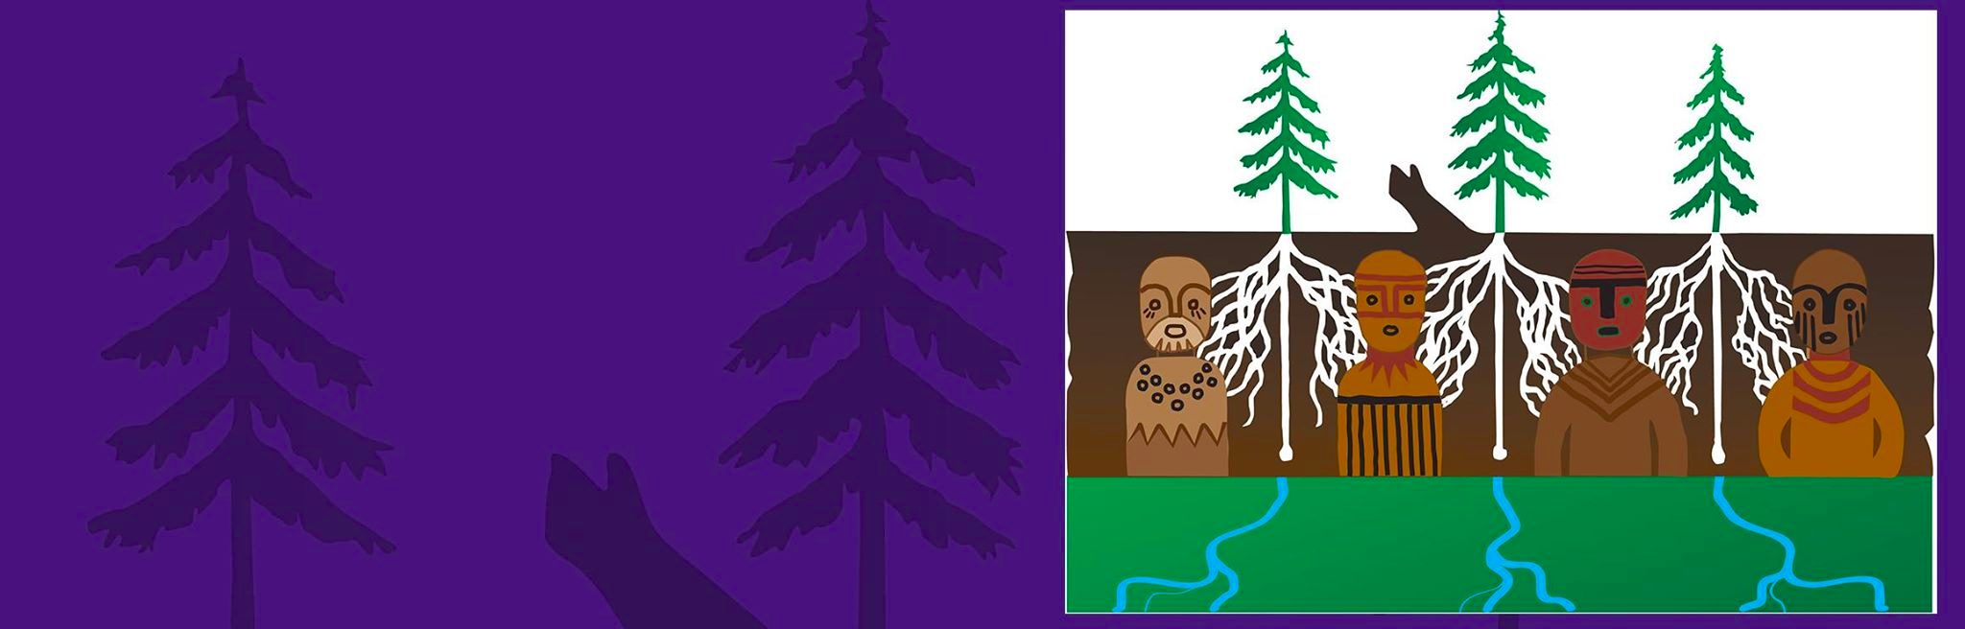
Artwork by Roger Fernandez

haʔɬ sləx̌il (Good Day),

We are inviting you, your community, and local school district employees to apply for the Native Education Certificate Program (NECP). The certificate offered at the University of Washington is a partnership between the College of Education and Professional and Continuing Education. The Native Education Certificate is a first of its kind in the nation where program participants develop knowledge in engaging Native students, families, and communities in teaching and learning practices that ensure Native student success in learning environments in ways that address the relevant needs of Native communities. This innovative program has developed with over 9 years of collaboration and vision by tribal citizens and University of Washington. We currently have seventeen board members, primarily tribal leaders and UW faculty who review all information and content.

The program is an online hybrid program (both online and in-person) utilizing a cohort model enabling peers to collaborate in scholarship and engage knowledge and skills with Native communities. Please see the included information for further details. For individual and cohort groups, considerations include:
      - A kick off with a three-day Summer Institute at the wǝɫǝbʔaltxʷ – Intellectual House on the University of Washington campus opens August 9, 10, 11, 2018.
- For groups of 10 participants from the same community and/or school district, we will offer a paid position for a Native liaison from your community to engage with the cohort.
- Districts and organizations interested in their own cohorts may pay for 25 enrollees and at no extra cost may register an additional 25 participants.
      - The June 30, 2018 deadline to enroll in this year’s cohort is quickly approaching!
If your cohort needs an extra week or so to gather information for submission, please contact us as soon as possible!

Why a certificate, and how could this be beneficial? We are aware all individual’s academic needs are different. We kept this in mind as participants look to further their education in various capacities:
- Opportunity to participate in an Experiential Project as part of National Boards Certifications and Native Education Certificate;
- Additional training as part of continuing education to remain endorsed or add an endorsement;
- Add undergraduate or graduate level credits to transfer in current education programs; or add graduate credits as an endorsement to teach as an adjunct at the college level;
- Acquire specific training to serve underrepresented populations in a culturally responsive way;
- Non-profits and organizations that work with tribal communities or governments will benefit by building understanding regarding tribal sovereignty, protocols and culturally responsive practices.

Please learn more with our:
- Scope and Sequence of Courses
- Native Certificate Flyer
- Frequently Asked Questions
- Application- Online submission or info@pce.uw.edu and dawnes@uw.edu

Also check out our website http://education.uw.edu/programs/necp! For any questions, please do not hesitate to contact the Program Manager, Dawn Hardison-Stevens at dawnes@uw.edu.

t̕igʷicid (Thank you),

Megan Bang, Ph.D. (Ojibwe)
Dawn Hardison-Stevens, Ph.D. (Swampy Cree/Cowlitz/Steilacoom)

